APPROVAL SHEET
FOR
DYNAMIC MINIATURE
SPEAKER

CUSTOMER:

SB P/N: JY 091602L50

CUSTOMER P/N:
CUSTOMER | APPROVER | CHECKER

深圳市高速通科技有限公司.
Add:深圳市宝安区西乡镇固戍文浩商务大厦B座8楼
Tel: 0755-36571778
Fax: 0573-27316080

DEYING | Product Specification |  | P/N | JY 091602L50
NO. | Issue: A0 | Revision Date: |  |  | Page:1/9
REVISION
No. | DATE | PAGE | Detail changes | SING

Table of contents
- Scope
- Environmental Requirement
- Electrical Requirements
- Acoustical Requirments
- Polarity Requirements
- Test Climatic Condition
- Test Method
- General Requirement
- General Reliability
- Mechanical Layout and Dimensions
- Weight
- Package

DEYING | Product Specification |  | P/N | JY 091602L50
NO. | Issue: A0 | Revision Date: |  |  | Page:2/9
1. Scope
This document contains required environmental, electrical, acoustic, mechanical, package
and reliability test requirements.
2. Environmental Requirement
The transducer including all components and solder joints must be free from lead (Pb) and
other banned or restricted substances according to customer's requirements.
- Electrical Requirements
3.1 Rated Impedance 8±15% ohms @2kHz, 1Vrms input

  - Rated Noise Power (in 1cc air) 0.5 Watts

3.3 Short Term Maximum Power (in 1cc air) 0.7Watts

4. Acoustical Requirements
4.1 Sound Pressure Level 78±3dB at 1Vrms/10cm at 2kHz

4.2 Bass Resonance Frequency
4.2.1 Resonance frequency in free air 600±15%Hz
4.2.2 Resonance frequency in 1cc box 800±15%Hz

4.3 Rated Frequency Range 500-10kHz
Frequency Response See Figure 1,Table 1
Test at 1Vrms/10cm

4.4 THD See Figure 2,Table 1
Test at 1Vrms/10cm
  - Rub & Buzz
A sine sweep among 100-1500Hz at rated noise power with 1cc back cavity will not result any buzzing or extraneous sound.

- Polarity Requirements
5.1 Polarity
When a DC source 2 s "+" polarity is attached to speaker's "+" polarity,
"-" polarity is attached speaker's "-" polarity, the membrane will move forward.

5.2 Magnetic Polarity
Top of the magnet is the north pole.

DEYING | Product Specification |  | P/N | JY 091602L50
NO. | Issue: A0 | Revision Date: |  |  | Page:3/9
Figure 1 Typical Frequency Response

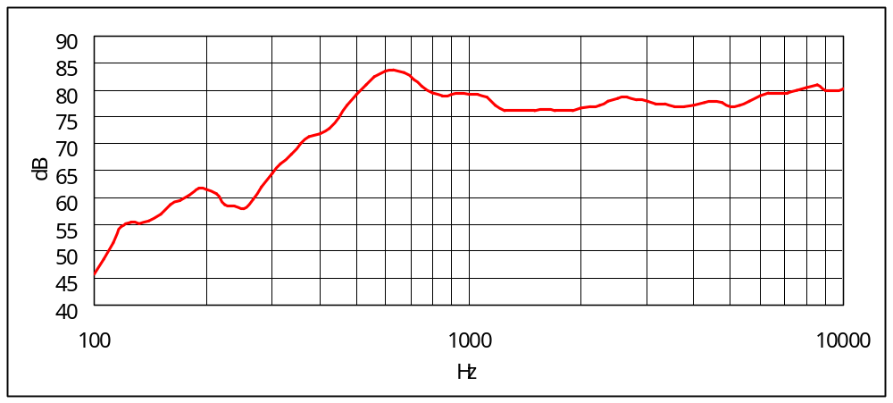

DEYING | Product Specification |  | P/N | JY 091602L50
NO. | Issue: A0 | Revision Date: |  |  | Page:4/9
Figure 2 Total harmonic distortion

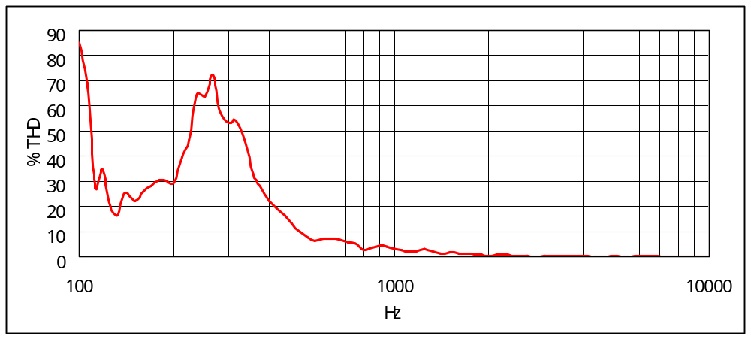

DEYING | Product Specification |  | P/N | JY 091602L50
NO. | Issue: A0 | Revision Date: |  |  | Page:5/9
6. Test Climatic Condition
Ambient temperature: 15℃- 35℃ , preferably at 20℃
Relative humidity: 25% to 75%
Air pressure : 86kPa - 106kPa
Refer to IEC 268-1

- Test Method
  - SPL and Frequency Response Curve
The loudspeaker shall be mounted in specified baffle , the measuring microphone shall be free-field microphone and placed at specified distance from DUT, on axis. The drive power is 1Vrms, and swept sine-wave range is 200Hz to 20kHz with a R40 of test sequence.

7.2 THD
Tested per Section 7.1 and driven at 1Vrms , sweep at specified frequency range
with R40 test sequence.

Figure 2 Test setup

Speaker Measurement Circuit

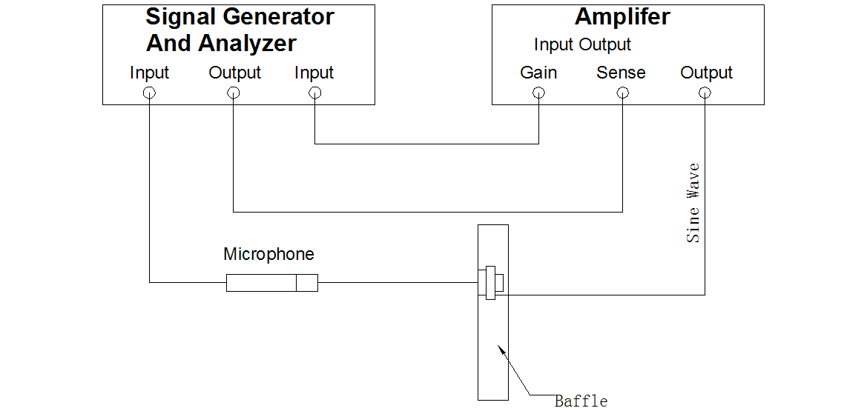

DEYING | Product Specification |  | P/N | JY 091602L50
NO. | Issue: A0 | Revision Date: |  |  | Page:6/9
8. General Requirements

9.1 Operating Temperature Range -20℃ to +70℃ without loss of function
9.2 Storage Temperature Range -40℃ to +85℃ without loss of function

9. General Reliability

Immediately after reliability test, the samples shall be stored under climatic conditions such as normally exist in ordinary rooms or laboratories. Unless otherwise noted, the recovery period shall be 4 hours at least before performance testing.
After reliability test, all samples must be meet the requirements specified in section 3 & 4.

9.1 Electrical Requirements:
-40℃ to +85℃ 10 cycles. 30 minutes at each temperature. 20 - 30 seconds transition time.Refer to IEC 68-2-14

9.2 Static Humidity Test :
Soak samples to +85°C with 85% relative humidity for continuous period of 168 hours.
Refer to IEC 68-2-67

9.3 Drop Test :
DUTs shall be mounted in a 100g fixture, drop samples 1.5m three times in each direction, total 18 times.

9.4 Operating Life :
DUTs shall be tested under each specified climatic condition (per section 6) for a
continuous period of 100 hours at rated noise power. Speakers mounted in a 1cc back
cavity;simulated program signal (IEC 268-1) with crest factor of 2;high pass 12dB/Oct
or steeper,cut off at 850Hz.
Refer to IEC 268-5.

9.5 Short Term Maximum Power :
DUTs shall be tested under each specified climatic condition (per section 6), Input shall be simulated program signal (per IEC 268-1) with crest factor of 1.8 to 2.2 in rated frequency response for a period of 1 second. And the test shall be repeated 60 times with intervals of 1 min.
Refer to IEC 268-5.

DEYING | Product Specification |  | P/N | JY 091602L50
NO. | Issue: A0 | Revision Date: |  |  | Page:7/9
10. Mechanical Layout and Dimensions

10.1 Mechanical Requirement for Speaker unit

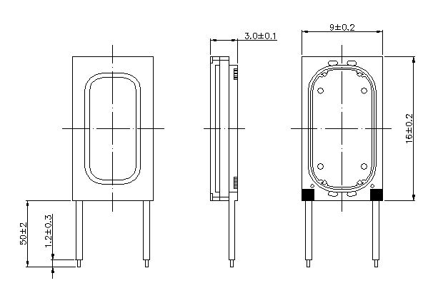

Notes:
1. General unless otherwise noted ±0.15mm
2.Spring force inside working area:0.2~1.5N

DEYING | Product Specification |  | P/N | JY 091602L50
NO. | Issue: A0 | Revision Date: |  |  | Page:8/9
11.2 Permitted Force to Speaker

Max.Permited compression forces:

No. | from | to | Maximum Permanent Force(N)
1 | F3 | F1
2 | F2
3 | F4 | F1
4 | F5

DEYING | Product Specification |  | P/N | JY 091602L50
NO. | Issue: A0 | Revision Date: |  |  | Page:9/9
- Weight

13. Package

TBD

